## Create basic k8s cluster.

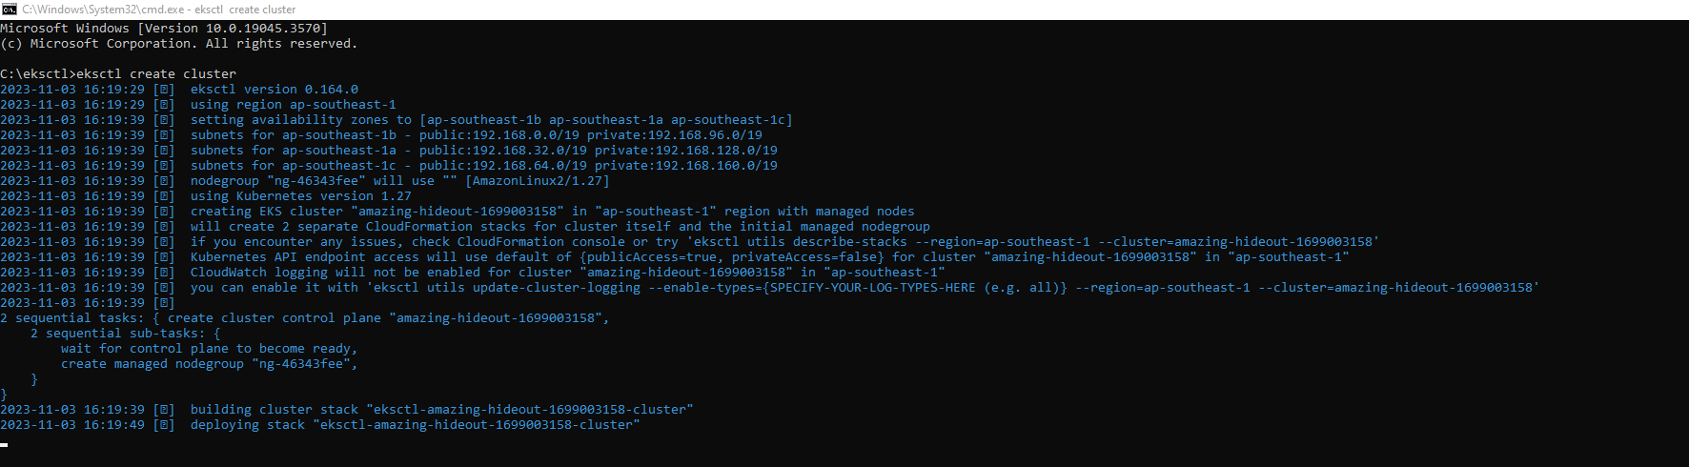

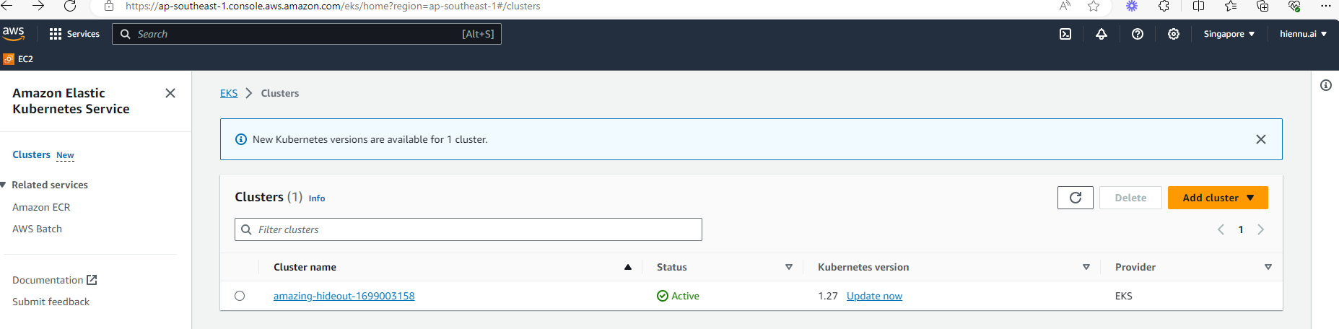



# Use helm charts to manage K8S manifest.